# **ICT3204 Group 3 Setup Documentation**

The following document details the steps to set up group 3’s Coursework 2 project.

## Uploading of Project Folder to Google Drive

Upload the Coursework 2 project folder to Google Drive by clicking on the Folder Upload button.

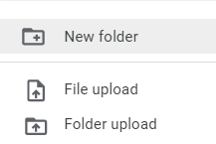

Figure 1. Folder Upload Feature

## Executing the Project Files

The following steps document the actions to execute the project.

Within the folder, double-click on both files to open them in Google Colab.

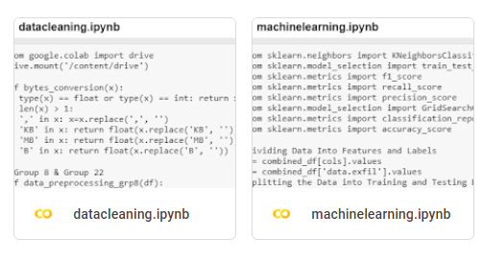

Figure 2. Google Colab Files

First, execute the datacleaning.ipynb file to perform the data preprocessing. Click on “Run all” under the Runtime dropdown list or Ctrl+F9 to run all of the code.



Figure 3. “Run all” Feature

The output of executing the entire Google Colab Notebook should output a DataExfil.csv in the processed subfolder in the datasets folder.

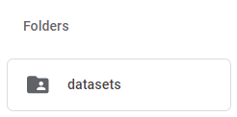

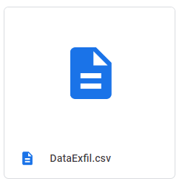

Figure 4. DataExfil.csv in datasets folder

With the outputted folder, the next step will be to execute the functions in machinelearning.ipynb file. Again, the same step as before, run all of the code by clicking on “Run all” in Google Colab.



Figure 5. “Run all” Feature

The models will be trained and tested before it is visualized using the ExplainerDashboard. Each model will be represented in its individual dashboard within the output of the cell. The dashboards will display the Classification Stats page which contains the statistics of the classification e.g. Performance Metrics, Confusion Matrix etc.

To view the various statistics:

1. Drag the circle of Cutoff percentile of samples to 0.01
2. Drag the circle of Cutoff prediction probability to 0.50

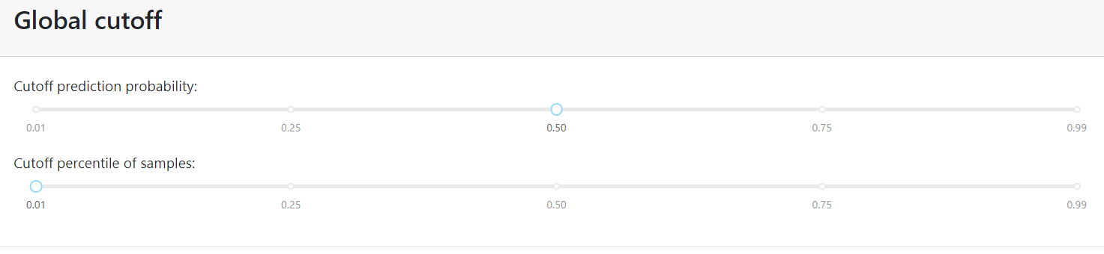

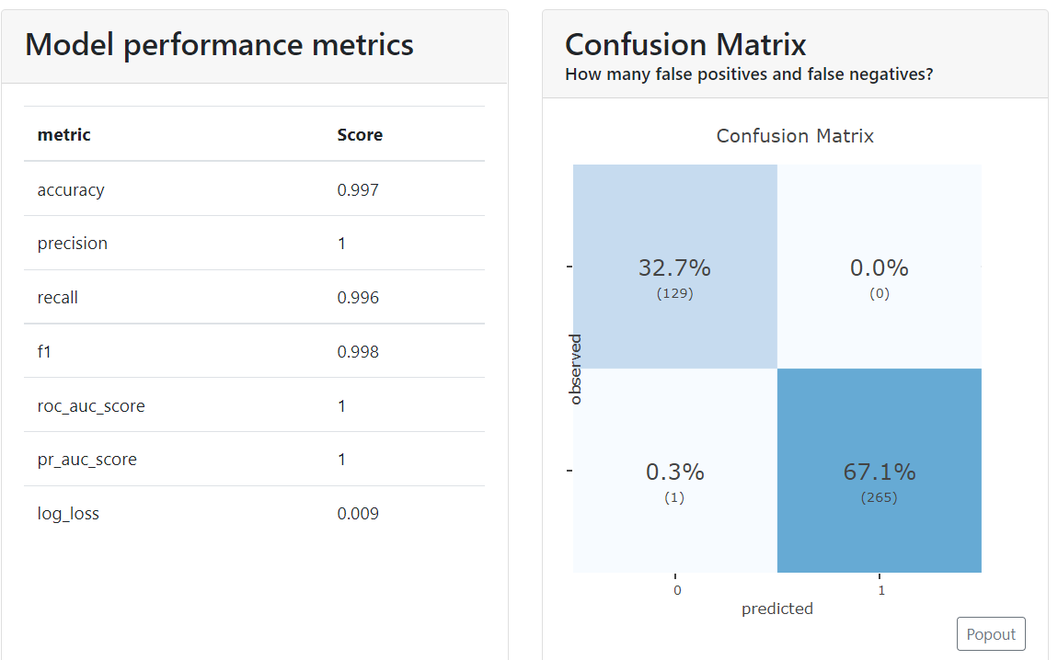

Figure 6. Classification Stats for KNN Model